Contents

Project definition 1

Background 1

Objectives and outcomes 1

Scope and exclusions 1

Constraints and assumptions 1

Users and other interested parties 2

Interfaces 2

Project approach 2

Business case 2

Project management team structure and roles 2

Quality management strategy 2

Risk management strategy 3

Communication management strategy 3

Project controls 3

Stage boundaries 3

Tolerances 3

Monitoring and reporting 3

Tailoring of PRINCE2 3

## Project definition

### Background

I accept a task of planning and managing the move.

The partnership is moving premises to a new building in the same town. While cabinets, bookshelves etc. will be transferred, new chairs and desks will be acquired.

A decision has been made to take the opportunity to upgrade most of its computer equipment.

### Objectives and outcomes

Make the movement goes smoothly and quickly after the available day.

### Scope and exclusions

The scope of the task include all the people and furniture, equipment, and software needed.

At first , we should move what

| Activities in Scope | Exclusions |
| --- | --- |
| The ability for students and staff to enter data about the student anywhere and anytime | Including a reporting function (data sort and export) |

### Constraints and assumptions

Constraints:

First, due to budget constraints

The four partners will be housed in individual offices, the other professional staff will be in three offices along with the assistants. The draftspersons will be in a separate office and the administration staff will be in the separate reception area.

Time limit : the offices will be available, empty, on Monday 30th October 2019 for you to start installation.

Many hareware and software should be added as the requirements.

Assumption:

There is available office equipment and their venues.

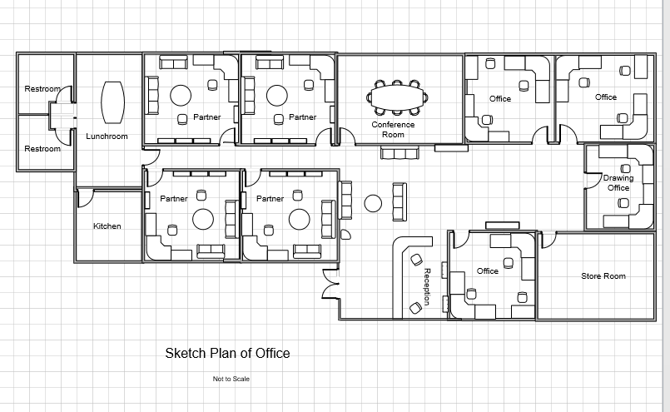

### Users and other interested parties

### Interfaces

## Project approach

## Business case

## Project management team structure and roles

Project Sponsor

Contractors

Your manager is one of the partners, George Tongariro

One of the assistants will be assigned to you for the duration. He has been learning about your computing setup so will be of use there.

## Quality management strategy

|  |  |  |
| --- | --- | --- |
| Activity | Measure | Possibile Reactification |
|  |  |  |
|  |  |  |
|  |  |  |

(table rows)

## Risk management strategy

|  |  |  |  |  |  |
| --- | --- | --- | --- | --- | --- |
| Risk Name | Likelihood | Control mechanisms |  |  |  |
|  |  |  |  |  |  |
|  |  |  |  |  |  |
|  |  |  |  |  |  |

## Communication management strategy

Using Agile method to welcome the changing requirements.

## Project controls

### Stage boundaries

### Tolerances

### Monitoring and reporting

contractors

## Tailoring of PRINCE2

A project plan produced using Microsoft Project, submitted through the Moodle dropbox, including the following:

* A set of tasks
* Durations
* A schedule
* Resources (including costings)
* Start and finish dates
* You are required to include a budget and timing for the project.
* You should charge your time out at $70 /hr. Others should be charged at $30/hr.
* You will be expected to do as much of the work as possible with your team.
* However, contractors can be hired for specialist tasks e.g. wiring, or heavy lifting.

Resources

You will be provided with the name and contact details of your client.

Other resources you use should be cited and referenced.

Background

You are the office manager/computer support manager for an engineering and surveying partnership. There are four partners, six other professional staff, two draftspersons, three assistants, two admin staff, and yourself.

The partnership is moving premises to a new building in the same town. While cabinets, bookshelves etc. will be transferred, new chairs and desks will be acquired.

A decision has been made to take the opportunity to upgrade most of its computer equipment.

The four partners will be housed in individual offices, the other professional staff will be in three offices along with the assistants. The draftspersons will be in a separate office and the administration staff will be in the separate reception area.

The offices will be available, empty, on Monday 30th October 2019 for you to start installation.

The partners, the other professional staff, and the draftspersons require networked desktop or tower computers. These computers will need to be high spec with large dual screens, and be equipped with graphic tablets/digitisers. There should be a heavy duty A4 laser colour printer and an A0 colour printer/plotter in the drafting office. The offices should each have light duty A4 printers available and it must be possible to send drawings to the printer/plotter from all workstations. The admin staff will each require a general computer and should print to a separate A4 printer in the reception area.

Wi-Fi access is required for laptops. These machines are already in use and will not be upgraded. All machines should have internet access.

All machines should run the latest Windows 10 and MS Office Professional. All machines other than those in admin should also have AutoCAD variants installed. The two surveyors require AutoCAD Map 3D while the rest require Autodesk Building Design Suite Premium. This is a minimum starting package, it is expected that other high-demand applications will be added over time.

You have been given the task of planning and managing the move. You will be able to call on help from the admin staff, but the reception should always be covered. One of the assistants will be assigned to you for the duration. He has been learning about your computing setup so will be of use there.

The move should be scheduled for a weekend when everyone will be able to pitch in to help.

Get as much as possible done before, or after moving day to minimise the impact on the others. You will be required to arrange the purchase of all the furniture, equipment, and software needed.

The firm recently upgraded its server and that has been suitably configured for storage, networking, and printing, and it will be moved from the previous premises. The new office space includes a storage room available to house the server. There is no existing computer wiring in the offices but the ceilings are tiled and have easy access. A plan of the premises will be supplied.

Your manager is one of the partners, George Tongariro, who has some experience with computers, but no detailed hardware or software knowledge. All information about requirements must be obtained from George via e-mail or from weekly meetings.

You are to manage the process using PRINCE2 and your first task is to prepare a Project Initiation Document outlining the project.

You are required to include a budget and timing for the project.

You should charge your time out at $70 /hr. Others should be charged at $30/hr.

You will be expected to do as much of the work as possible with your team.

However, contractors can be hired for specialist tasks e.g. wiring, or heavy lifting.